So you're hooked on the world of graphic design and ready to take the plunge? Here are some key pieces of advice to fuel your creative journey.

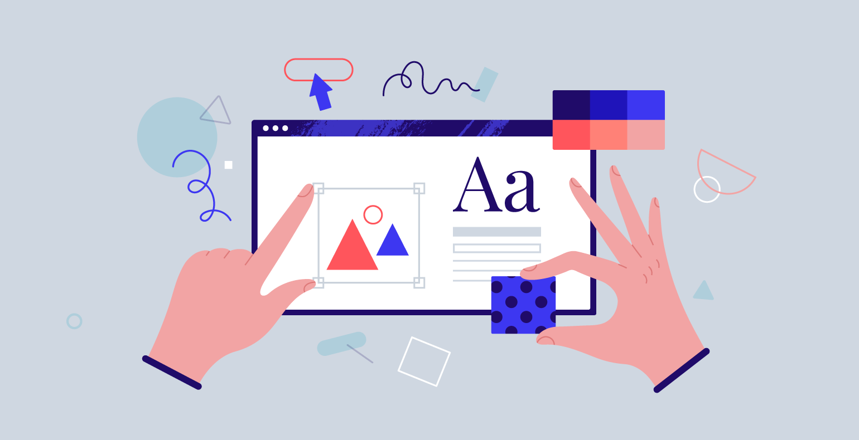

Firstly, develop a keen eye for design. Surround yourself with inspiring visuals – visit museums, browse design blogs, and analyze the graphics you encounter daily. Pay attention to color palettes, typography choices, and layout principles. This constant visual training will refine your sense of what works and what doesn't, building a strong foundation for your own design decisions.

Next, hone your technical skills. Mastering design software like Adobe Photoshop and Illustrator is essential. There are countless online tutorials and courses available to get you started. Practice consistently, working on personal projects to explore different design styles and techniques. Don't be afraid to experiment – the more you create, the more you'll discover your strengths and develop a unique design voice.

Finally, build your network and learn from the community. Connect with other designers online and offline, attend workshops and conferences, and participate in design challenges. This interaction will expose you to diverse perspectives, keep you up-to-date on industry trends, and open doors to potential collaborations. Remember, the design world is a vibrant community – embrace the opportunity to learn and grow together.